ZEPTO ANALYSIS USING POSTGRESQL

OBJECTIVE: Build SQL Data Analyst Portfolio Project of Zepto Data.

STEP 1: Collect data of Zepto from Kaggle.

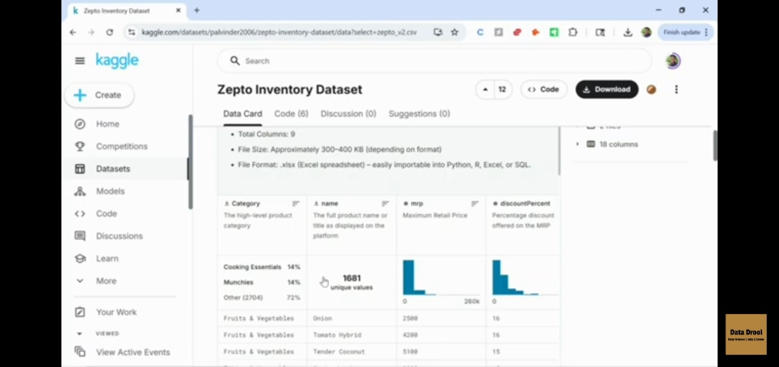

STEP 2: Create database in PostgreSQL which is opened as pgAdmin4

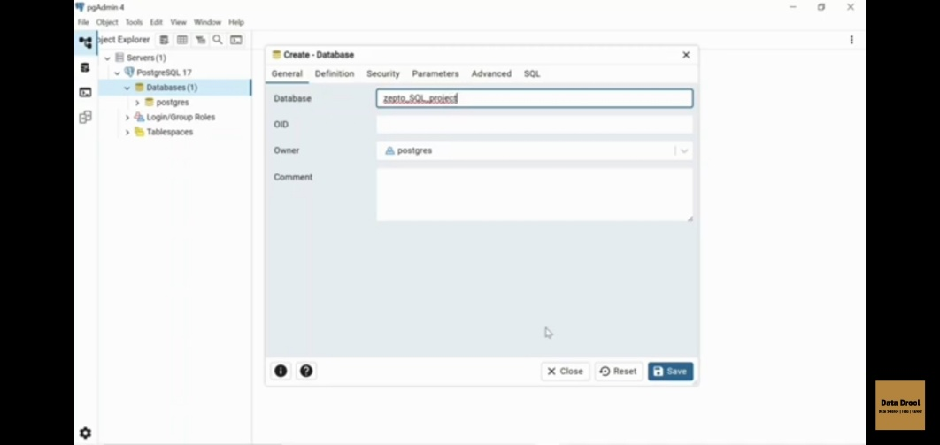

STEP 3: Create a table which has the following columns that are present in the Inventory.

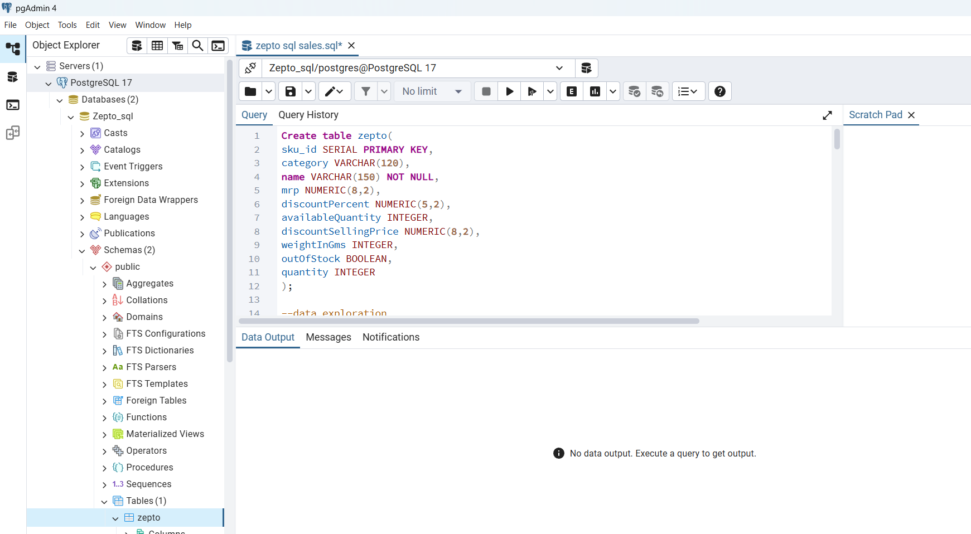

STEP 4: Import the data into PostgreSQL as cv format.

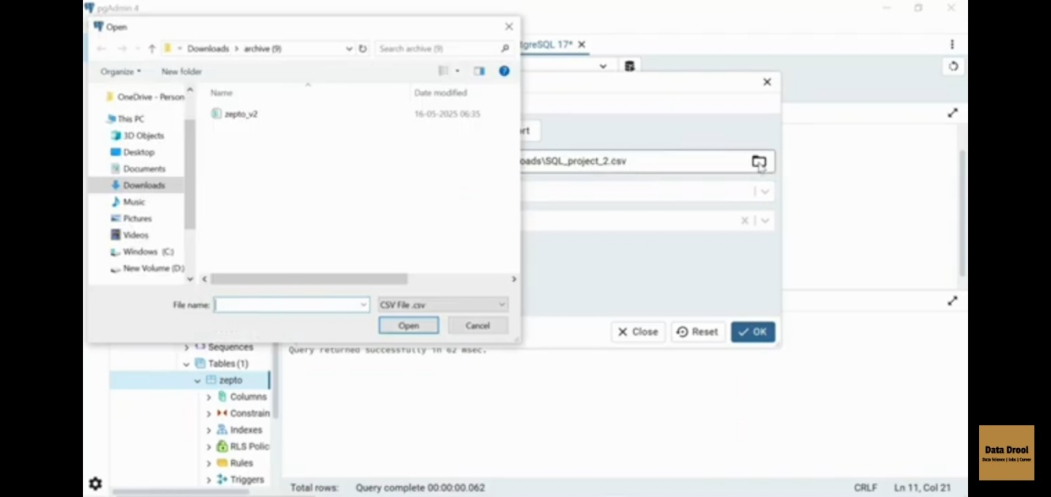

STEP 5: Data Exploration

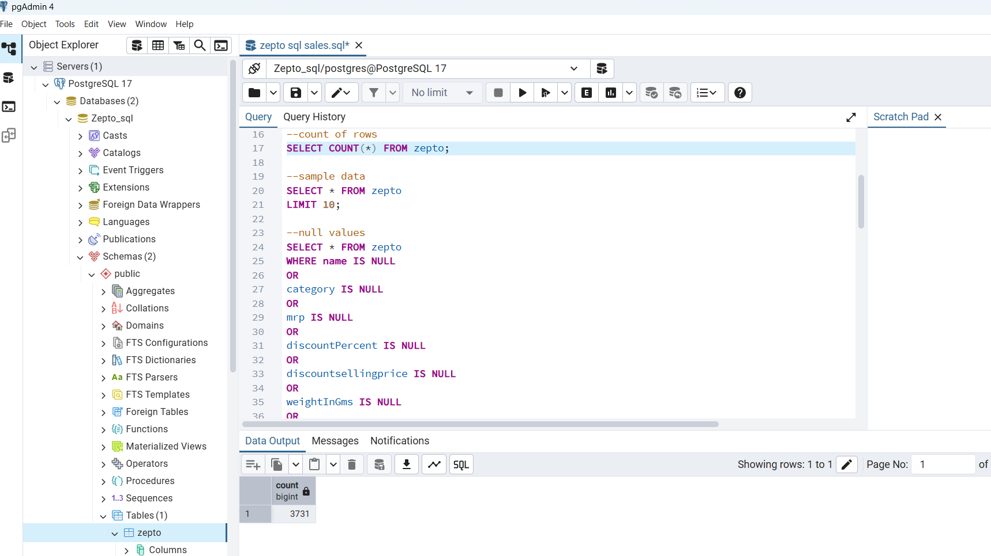

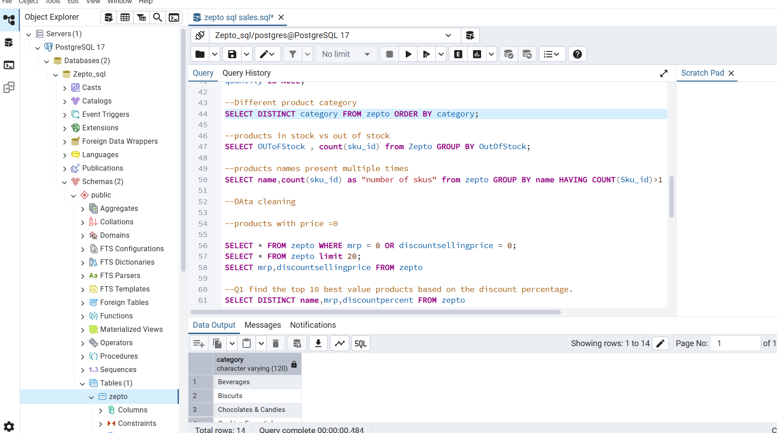

STEP 6: Data Cleaning

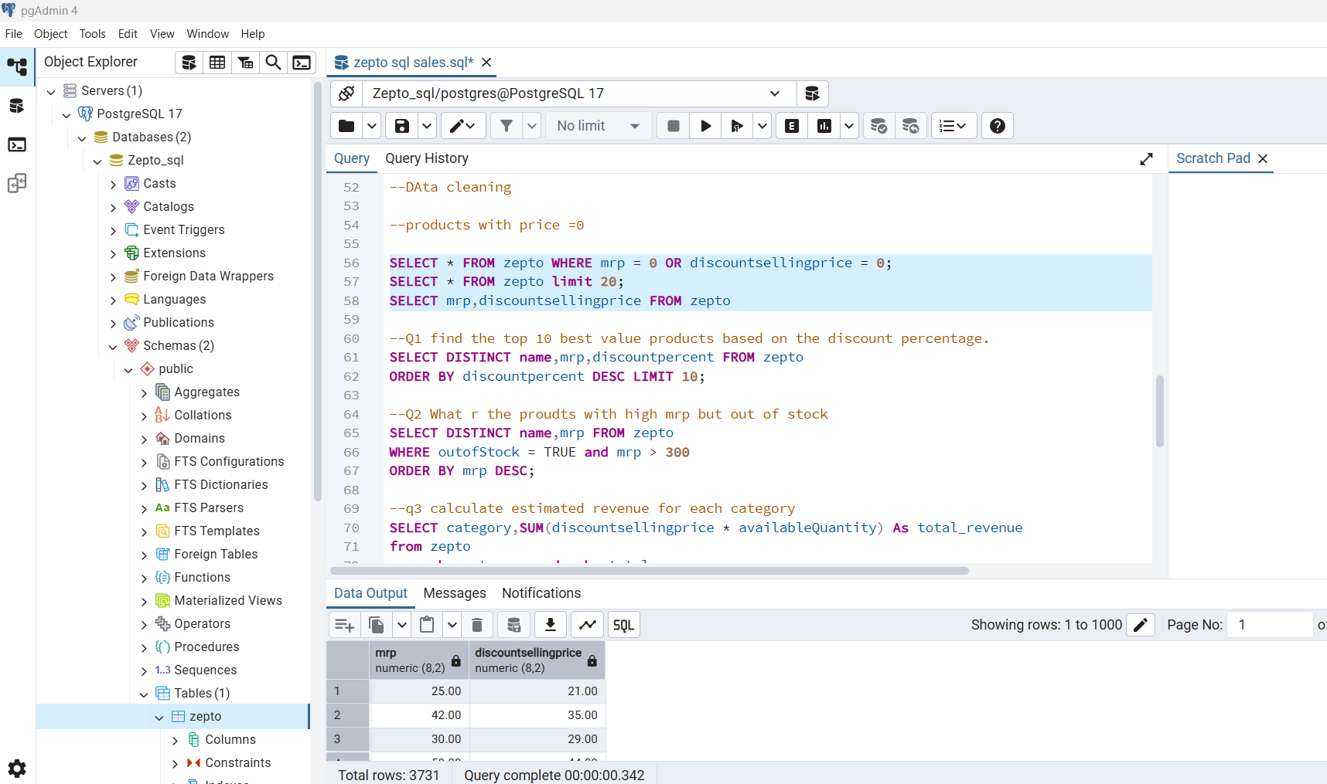

STEP 7: Q1 find the top 10 best value products based on the discount percentage.

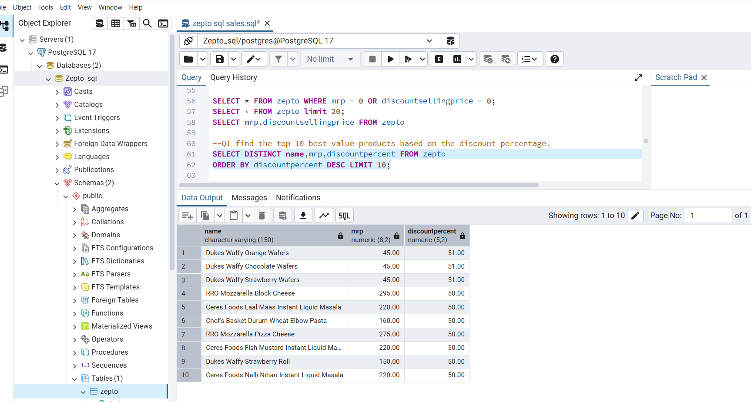

Q2 What r the products with high mrp but out of stock

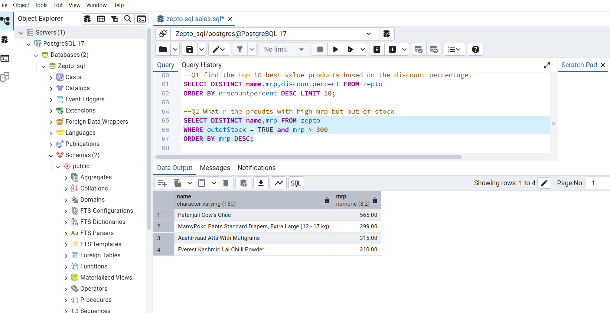

Q3 calculate estimated revenue for each category

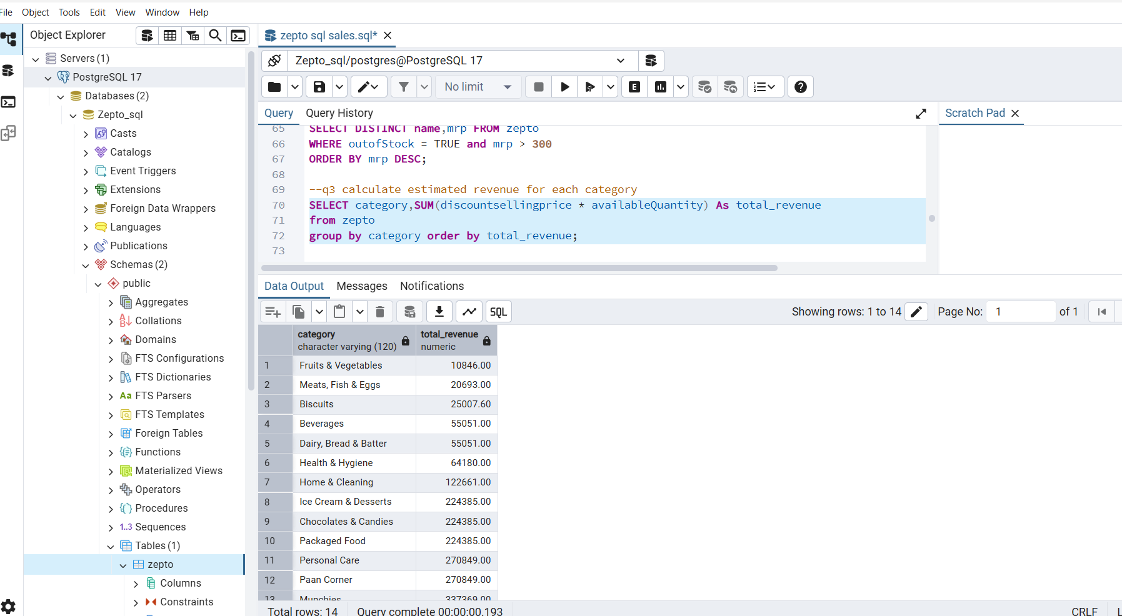

Q4 find all products where mrp is greater than 500 and discount is less than 10%

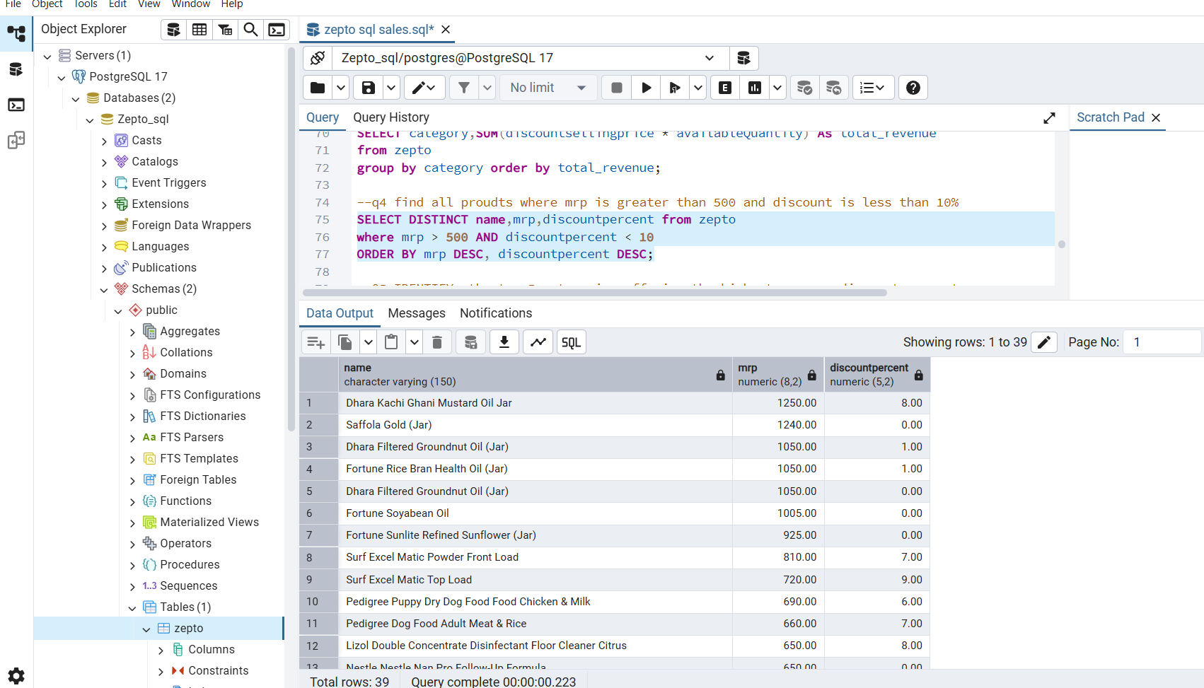

Q5 IDENTIFY the top 5 categories offering the highest average discount percentage

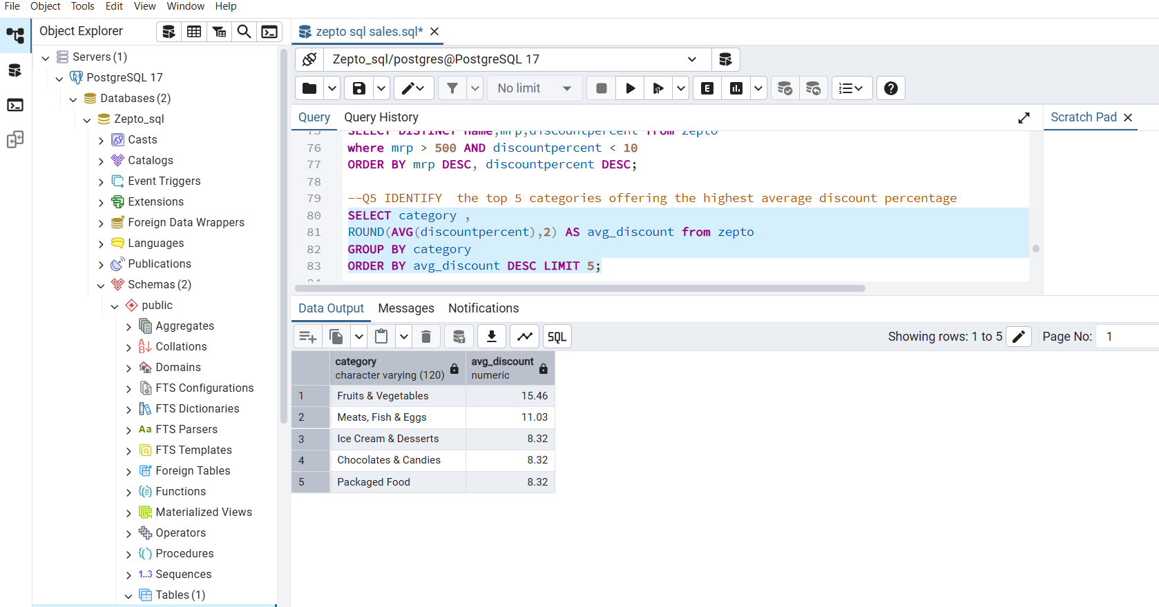

Q6 find the price per gram for products above 100g and sort by best value.

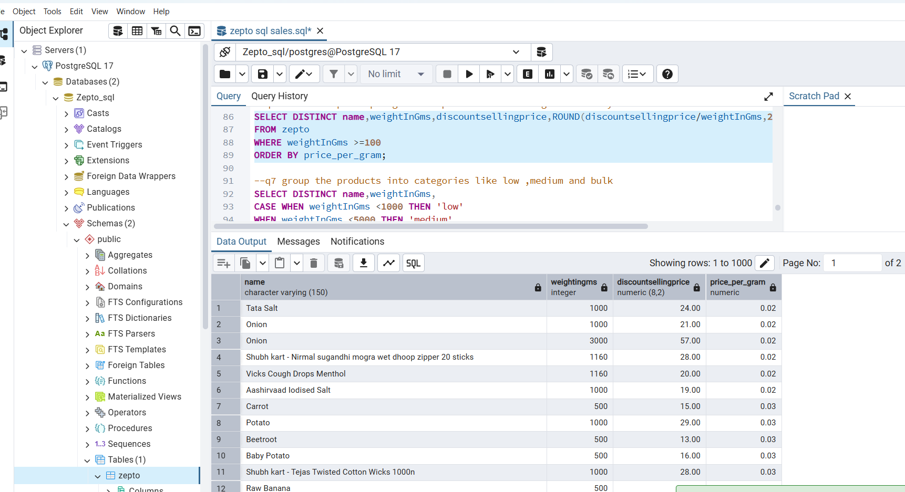

Q7 group the products into categories like low, medium and bulk

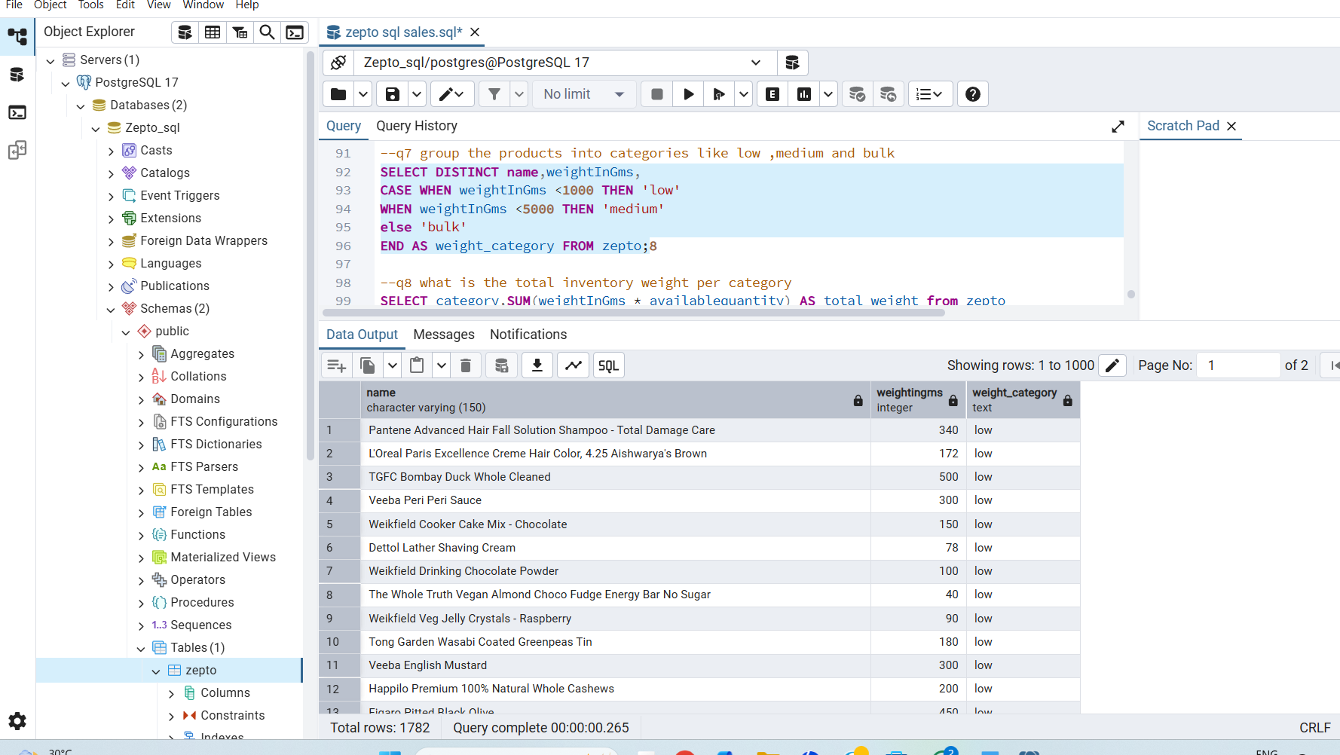

Q8 what is the total inventory weight per category

